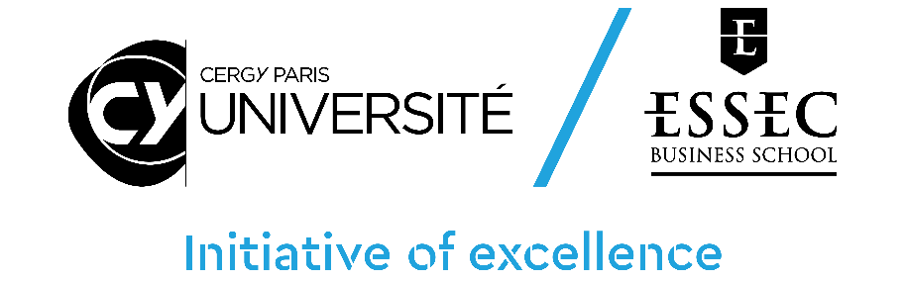

CY Générations – Call for Proposals 2023

HORIZON program
Application Document

Please use the following form to provide information on your application. Please complete all sections unless specified as optional.
For queries email aap-cy-initiative@cyu.fr

NB :
- Applications should be submitted through the online platform-https://cy-initiative.smapply.io
- This form is part of the application material and should be submitted online as a pdf document
- Applications which do not use this template, or which do not comply with the prescribed section limits or which modify the layout or formatting of the template in any way, will be considered ineligible and will be excluded from further review.
- The minimum font size allowed is 11 points. Standard character spacing and a minimum of single line spacing is to be used. Text elements other than the body text, such as headers, foot/end notes, captions, formulae, may deviate, but must be legible; however, these elements should not be used as mechanism to circumvent the rules."

1. APPLICANT DETAILS (PRINCIPAL INVESTIGATOR)
First Name
Last Name
Email Address
Phone number
Institution |  | If other specify:
Research Center 1 |  | If other specify:
Research Center 2 |  | If other specify:
Other research centers involved

2. SUMMARY OF RESEARCH PROPOSAL
Proposal Title
Proposal Acronym
Amount Requested | €

3.a ABSTRACT (in english)

3.b RÉSUMÉ (en français)

4. SCIENTIFIC PROJECT (Please provide a detailed description of the research hypothesis and objectives, as well as the programme and methodology. Maximum 5 pages)

Describe: (i) the scientific objectives of the research project; (ii) the context and relevance of the scientific project in relation to the state of the art; (iii) scientific results expected from the project; (iv) the researchers involved, the relevance of their respective expertise for the project and its expected results (CVs of the Principal Investigator and other researchers should be included in the appendix document).

4. SCIENTIFIC PROJECT (Continued) page 2

4. SCIENTIFIC PROJECT (Continued) page 3

4. SCIENTIFIC PROJECT (Continued) page 4

4. SCIENTIFIC PROJECT (Continued) page 5

4bis. SCIENTIFIC PROJECT - CY GENERATIONS SPECIFITIES (Please provide a detailed description of the multidisciplinary approach and Sustainable Development Goals of the project)

Describe: (i) the multidisciplinary approach, (ii) the Sustainable Development Goals supported, by promoting the priority areas of CY Générations (repair & care; produce and consume; build & organise society; promote solidarity & inclusive education).

5. EXPERTISE OF THE RESEARCH GROUP (Maximum 2 pages)

Describe the composition of the research group, the expertise of the researchers involved, their complementarity and expected contribution to the project (CVs of the Principal Investigator and other researchers should be included in the appendix document).

5. EXPERTISE OF THE RESEARCH GROUP (Continued) page 2

6. STRATEGIC NATURE OF THE PROJECT (Discuss the strategic nature of the project at various levels (host research centers, principal investigator and other researchers, the CY Initiative of excellence as a whole. Maximum 2 pages)
Discuss the leverage effect expected from the project on the strategic scientific positioning of the implicated research team(s), including their international visibility, partnerships and attractiveness; discuss, in this context, the synergies with other strategic research projects developed by the team and research centers, as well as interactions of the project within the broad context of the CY Initiative; special attention shall be given to the anticipated impact of the project compared to the current situation in terms of scientific positioning (e.g. scientific barriers that the project will allow to lift), international visibility, impact and outreach (including societal relevance of the project and dissemination strategies).

6. STRATEGIC NATURE OF THE PROJECT (Continued) page2

7. IMPACT IN TERMS OF INTERNATIONALISATION AND SCIENTIFIC VISIBILITY (Maximum 1 page)
Discuss the objectifs related to the project in terms of outreach and visibility at the national and international levels, attractiveness, development of international scientific collaborations and partnerships the research team(s) plan to achieve within the project.

8. IMPACT IN TERMS OF VALORIZATION, INNOVATION, SOCIO-ECONOMIC PARTNERSHIP AND TRAINING (Maximum 1 page)
When relevant, discuss the contribution of the project in terms of technological transfers (patents, software, etc.), external non-academic partnership. Discuss contributions to instrumentation and technological platforms. Discuss possible contributions of the project to training programs.

9. SUSTAINABILITY OF THE PROJECT AND FUNDING STRATEGY (Explain how additional funding shall be secured and which other means shall be developed to guarantee the sustainability of the project. Maximum 2 page)
(i) Discuss the medium run sustainability and funding strategy, including cofinancing and external funding (which sorts of funding and at what stage of the project) and provide full details on the funding program that the research team will commit to apply to (Horizon Europe, ERC, ANR, FET, etc.).
(ii) If ANY researcher involved in the project has received funding under previous Paris Seine/ CY Initiative calls (2017, 2018, 2019, 2020), the scientific progress of the former projects shall be specified, as well as links to the proposal and its scientific objectives; explain how the current proposal can strengthen the dynamic of excellence already launched.

9. SUSTAINABILITY OF THE PROJECT AND FUNDING STRATEGY (Continued)

10. JUSTIFICATION OF THE MEANS REQUESTED (Maximum 2 pages)
(i) Provide a justification for the amounts requested. Provide all details on co-financing sources including source of co-financing, identity of the co-financing institutions. State whether co-financing has been obtained, prospective or needs to be contractualized;

10. JUSTIFICATION OF THE MEANS REQUESTED (Continued)
(ii) Provide a table summarizing the amount requested from the CY Initiative as well as possible co-financing obtained or to be obtained from other sources.

 | Call 2021 funding | Co-funding name of the financing partner | Co-funding name of the financing partner | Co-funding  name of the financing partner | Total | NUMBER OF PERSON-MONTHS FINANCED
Personnel expenses
Operating budget |  |  |  |  |  | -
 |  |  |  |  |  | -
 |  |  |  |  |  | -
 |  |  |  |  |  | -
 |  |  |  |  |  | -
Missions |  |  |  |  |  | -
 |  |  |  |  |  | -
 |  |  |  |  |  | -
 |  |  |  |  |  | -
 |  |  |  |  |  | -
Total

11. PROJECT TIMELINE (Maximum 1 page)
Indicate the starting date of the project and main milestones, including starting date for possible hiring and taking into account the necessity to organize job advertisement and selection procedures.

