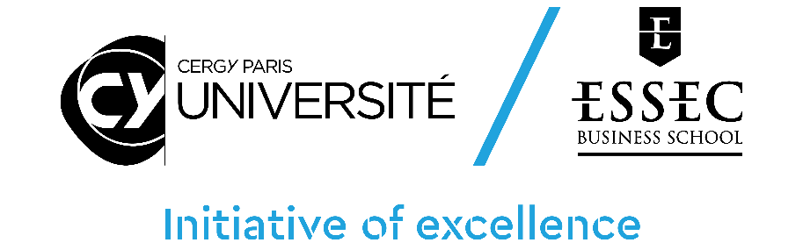
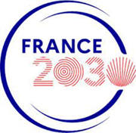

CY Générations – Call for Proposals 2023

EMERGENCE programme
Application Document

Please use the following form to provide information on your application. Please complete all sections unless specified as optional.
For queries email aap-cy-initiative@cyu.fr

NB :
- Applications should be submitted through the online platform- https://cy-initiative.smapply.io
- This form is part of the application material and should be submitted online as a pdf document
- Applications which do not use this template, or which do not comply with the prescribed section limits or which modify the layout or formatting of the template in any way, will be considered ineligible and will be excluded from further review.
- The minimum font size allowed is 11 points. Standard character spacing and a minimum of single line spacing is to be used. Text elements other than the body text, such as headers, foot/end notes, captions, formulae, may deviate, but must be legible; however, these elements should not be used as mechanism to circumvent the rules.

1. APPLICANT DETAILS (PRINCIPAL INVESTIGATOR)
First Name
Last Name
Email Address
Phone number
Institution |  | If other specify:
Research Center 1 |  | If other specify:
Research Center 2 |  | If other specify:
Other research centers involved

2. SUMMARY OF THE PROPOSAL
Proposal title
Proposal acronym
Amount requested | €

3.a ABSTRACT (in english)

3.b RÉSUMÉ (en français)

4. SCIENTIFIC PROJECT (Please provide a detailed description of the research hypothesis and objectives, as well as the programme and methodology. Maximum 3 pages)

Describe: (i) the scientific objectives of the research project, (ii) the context and relevance of the scientific project in relation to the state of the art; (iii); the researchers involved and supervision arrangement, including, where relevant, international or socio-economic partners (CVs of the Principal Investigator and other researchers will be included in the appendix document).

4. SCIENTIFIC PROJECT (Continued) page 2

4. SCIENTIFIC PROJECT (Continued) page 3

4bis. SCIENTIFIC PROJECT - CY GENERATIONS SPECIFITIES (Please provide a detailed description of the multidisciplinary approach and Sustainable Development Goals of the project)

Describe: (i) the multidisciplinary approach, (ii) the Sustainable Development Goals supported, by promoting the priority areas of CY Générations (repair & care; produce and consume; build & organise society; promote solidarity & inclusive education).

5. STRATEGIC NATURE AND SUSTAINABILITY OF THE PROJECT (Discuss the strategic nature of the project at various levels (project leader, researchers involved, host research centers, the Paris Seine Initiative of excellence as a whole. Maximum 2 page)
(i) Discuss the leverage effect expected from the project ; barriers that the project will allow to lift in the scientific domain and the field of international visibility; syngergies between the project and other research projects of the PI, the research center and interactions within the broad context of the Paris Seine Initiative; links with external partners (research laboratories, companies, local authorities);
(ii) Discuss the medium run sustainability strategy, including full details on the funding program that the research team will commit to apply to (H2020/Europe, ERC, ANR, FET, etc.).

5. STRATEGIC NATURE AND SUSTAINABILITY OF THE PROJECT (Continued) page 2

6. IMPACT IN TERMS OF INTERNATIONALISATION AND SCIENTIFIC VISIBILITY (Maximum 1 page)
Discuss the contribution of the project in terms of outreach and visibility at the national and international levels, attractiveness, development of international scientific collaborations and partnerships.

7. IMPACT IN TERMS OF VALORIZATION, INNOVATION, SOCIO-ECONOMIC PARTNERSHIP AND TRAINING (Maximum 1 page)
When relevant, discuss the contribution of the project in terms of technological transfers (patents, software, etc.), external non-academic partnership. Discuss contributions to instrumentation and technological platforms. Discuss possible contributions of the project to training programs.

8. SCIENTIFIC PROGRESS, IN CASE OF PREVIOUS FUNDING UNDER THE 2017, 2018, 2019, 2020 or 2021 CALLS FOR PROPOSALS (Researchers need to demonstrate a strong progress in the objectives they had previously set in order to be considered for additional funding. Maximum 1 page)
If any of the researchers involved in the proposal was previously supported under an ISITE funded project specify the impact of the previous funding and the way the current project elaborates on previous achievements.

9. JUSTIFICATION OF THE MEANS REQUESTED (Maximum 2 page)
(i)Provide a justification for the amounts requested. Provide all details on co-financing sources including source of co-financing, identity of the co-financing institutions, whether co-financing has been obtained, prospective or needs to be contractualized;

9. JUSTIFICATION OF THE MEANS REQUESTED (Continued) page 2
(ii) Provide a table summarizing the amount requested from the Paris Seine Initiative as well as possible co-financing obtained or to be obtained from other sources.

 | Call 2021 funding | Co-funding name of the financing partner | Co-funding name of the financing partner | Co-funding name of the financing partner | Total | NUMBER OF PERSON-MONTHS FINANCED
Personnel expenses
Operating budget |  |  |  |  |  | -
 |  |  |  |  |  | -
 |  |  |  |  |  | -
 |  |  |  |  |  | -
 |  |  |  |  |  | -
Missions |  |  |  |  |  | -
 |  |  |  |  |  | -
 |  |  |  |  |  | -
 |  |  |  |  |  | -
 |  |  |  |  |  | -
Total

10. PROJECT TIMELINE (Maximum 1 page)
Indicate the starting date of the project and main milestones, including starting date for possible hiring and taking into account the necessity to organize job advertisement and selection procedures.

