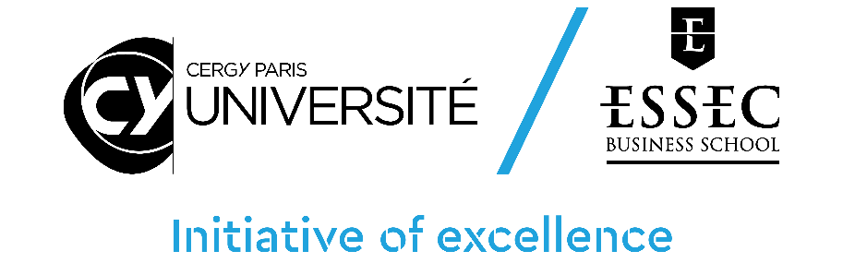

CY Initiative & CY Generations – Call for Proposals 2024

HORIZON program
Application Document

Please use this form to provide information on your application. If you apply to the CY Generations call, complete all sections (blue & green). If you apply only to the CY initiative call, complete only the blue sections (all sections except 5bis & 6bis).

- This form is part of the application material and should be submitted as a pdf document through the online platform-https://cy-initiative.smapply.io
- Applications which do not use this template, or which do not comply with the prescribed section limits, or which modify the layout or formatting of the template in any way, will be considered ineligible and will be excluded from further review. The blue & green cartridges containing instructions must be retained in their entirety.
- The minimum font size allowed is 11 points. Standard character spacing and a minimum of single line spacing is to be used. Text elements other than the body text, such as headers, foot/end notes, captions, formulae, may deviate, but must be legible; however, these elements should not be used as mechanism to circumvent the rules.

For any questions email aap-cy-initiative@cyu.fr

1. APPLICANT DETAILS (PRINCIPAL INVESTIGATOR)
First Name
Last Name
Email Address
Phone number
Institution
Research Centre

2. SUMMARY OF RESEARCH PROPOSAL
Proposal Title
Proposal Acronym (Maximum 15 letters)
Amount Requested (Maximum 200 000 €) | €

3.ABSTRACT (in English, Maximum 300 words)

3bis. RESUME (en Français, Maximum 300 mots)

4. SCIENTIFIC PROJECT (Maximum 5 pages)
Describe: (i) the scientific objectives of the research project;
(ii) the context and relevance of the scientific project in relation to the state of the art;
(iii) research hypothesis and scientific results expected from the project;
(iv) scientific programme and methodology to reach the objectives.

5. EXPERTISE OF THE RESEARCH GROUP (Maximum 2 pages)
Describe the composition of the research group, the expertise of the researchers involved, their complementarity and expected contribution to the project (CVs of the Principal Investigator and other researchers should be included in the appendix document).

5bis. MULTIDISCIPLINARITY (only for CY Generations applications, maximum 1 page)
Describe: (i) the multidisciplinary approach and adequacy to the research project;
(ii) Distribution of the scientific expertise for each discipline and for the multidisciplinary aspects within the research group.

6. STRATEGIC NATURE OF THE PROJECT (Maximum 2 pages)
(i) discuss the leverage effect expected from the project on the strategic scientific positioning of the research team at various levels (individual, research centres, institutions), including international visibility, partnerships and attractiveness; discuss, in this context, the synergies with other strategic research projects and policies of the team, the research centres and institutions.
(ii) describe the anticipated impact of the project in terms of scientific positioning (e.g. scientific barriers that the project will allow to lift), international visibility, attractiveness, scientific collaborations and outreach (including societal relevance of the project and dissemination strategies).
(iii) describe the impact of the project in term of valorisation, innovation, socio-economic partnership and training: when relevant, discuss the contribution of the project for technological transfers (patents, software, etc.), external non-academic partnership, to instrumentation and technological platforms, and possible contributions to training programs.

6bis SUSTAINABLE DEVELOPMENT GOALS (only for CY Generations applications, maximum 1 page)
Describe: (i) the Sustainable Development Goals (SDG) supported, by promoting the priority areas of CY Generations (repair & care; produce and consume; build & organize society; promote solidarity & inclusive education); argue the impact of the scientific project on those SDG.
(ii) the contribution of multidisciplinarity to the challenged SDG.
(iii) when relevant, discuss possible technological and social transfers with relation to transition.

7. SUSTAINABILITY OF THE PROJECT (Maximum 2 pages)
Explain the strategy for building a successful application for large-scale external funding, as expected in this call, and possibly how additional funding or other means can be obtained to guarantee the sustainability of the project.

7 bis. SCIENTIFIC PROGRESS IN CASE OF PREVIOUS FUNDING FROM CY INITIATIVE & CY GENERATIONS (Maximum 1 page)
If any of the researchers involved in the proposal was previously supported under a CY Initiative or CY Generations funded project, provide the reference of the previous programmes, specify the impact and the way the current project elaborates on previous achievements. Researchers need to demonstrate strong progress in the objectives they had previously set to be considered for additional funding.

8. JUSTIFICATION OF THE MEANS REQUESTED (Maximum 2 pages + tables)
Provide a justification for the amounts requested. Provide all details on co-financing sources including source of co-financing, identity of the co-financing institutions. State whether co-financing has been obtained, prospective or needs to be contractualized.

Tables for section 8. JUSTIFICATION OF THE MEANS REQUESTED
Provide a table summarizing the amount requested from the CY Initiative / CY Generations as well as possible co-financing obtained or to be obtained from other sources.
If your internal team includes researchers from several institutions, please specify the distribution of funding in the second table.
Add columns or lines if necessary.

 |  | Call 2024 funding | co-funding 1 | co-funding 2 | co-funding 3 | Total amount
 |  |  | [partner name] | [partner name] | [partner name]
Payroll | Number of person-months financed | € | € | € | € | €
 |  | € | € | € | € | €
 |  | € | € | € | € | €
 |  | € | € | € | € | €
 |  | € | € | € | € | €
 |  | € | € | € | € | €
 |  | € | € | € | € | €
Investment |  | € | € | € | € | €
 |  | € | € | € | € | €
 |  | € | € | € | € | €
 |  | € | € | € | € | €
 |  | € | € | € | € | €
 |  | € | € | € | € | €
 |  | € | € | € | € | €
Operating Budget |  | € | € | € | € | €
 |  | € | € | € | € | €
 |  | € | € | € | € | €
 |  | € | € | € | € | €
 |  | € | € | € | € | €
 |  | € | € | € | € | €
 |  | € | € | € | € | €
Total |  | € | € | € | € | €

Call 2024 funding distribution | Lab 1 [name] | Lab 2 [name] | Lab 3 [name] | Lab 4 [name] | Lab 5 [name]
Payroll
Investment
Operating Budget
Total

9. PROJECT TIMELINE (Maximum 1 page)
Indicate the starting date of the project and main milestones, including starting date for possible hiring and considering the necessity to organize job advertisement and selection procedures.

